Majestic Fall Promo Toolkit
This toolkit includes educational and promotional posts that can help you highlight the fall promo across your social media channels. Utilize the provided post copy and add a call-to-action that encourages consumers to visit your showroom or request a consultation.
Creative | Post Copy
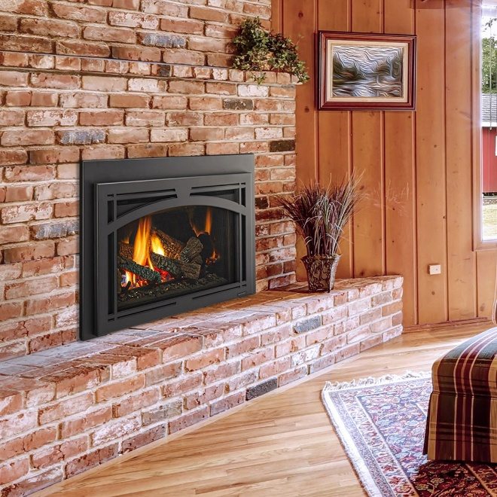 | Did you know? Installing a gas insert in your old wood fireplace can dramatically boost heating efficiency.  These inserts are designed to contain and radiate more heat back into your room, rather than letting it escape up the chimney.
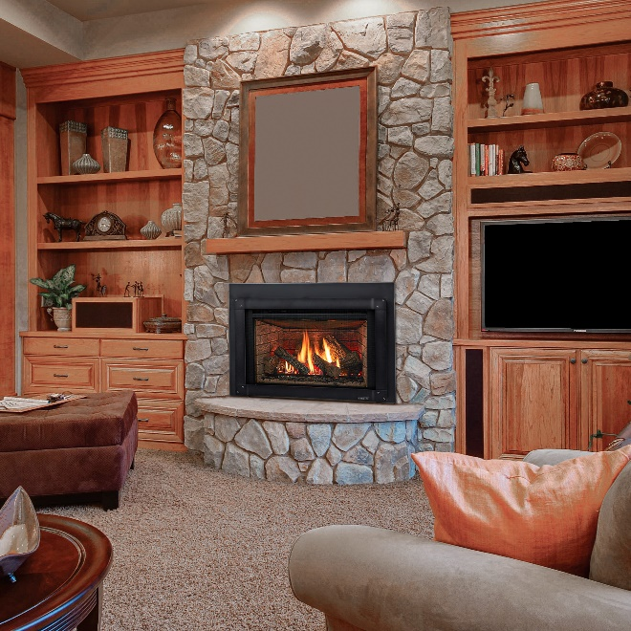 | Did you know? Converting your traditional wood fireplace to a modern gas insert is easier than you think.  Our experts can typically complete the installation in just one day, offering an easy upgrade to improve your home's heating efficiency
 | Tired of the mess and hassle of your wood fireplace? Switch to a Majestic gas insert and enjoy cozy warmth at the touch of a button. Save up to $650 for a limited time only!
 | Ready for your fireplace makeover? Transform your old wood fireplace into an efficient Majestic gas insert and save up to $650!
 | Say goodbye to chopping wood and hello to convenience! Transform your old fireplace with a Majestic gas insert and save up to $650.
 | The reasons to upgrade your old fireplace to a Majestic gas insert? Too many to count! Enjoy efficiency and convenience when you upgrade and save up to $650.
 | From outdated to outstanding! Give your old wood fireplace a modern makeover with a Majestic gas insert. Experience effortless warmth and style – and save up to $650 on your upgrade!

